Lab M1.01 - Programming Foundation Exercises
Cindy Lund
Test with “AWAY”
1.

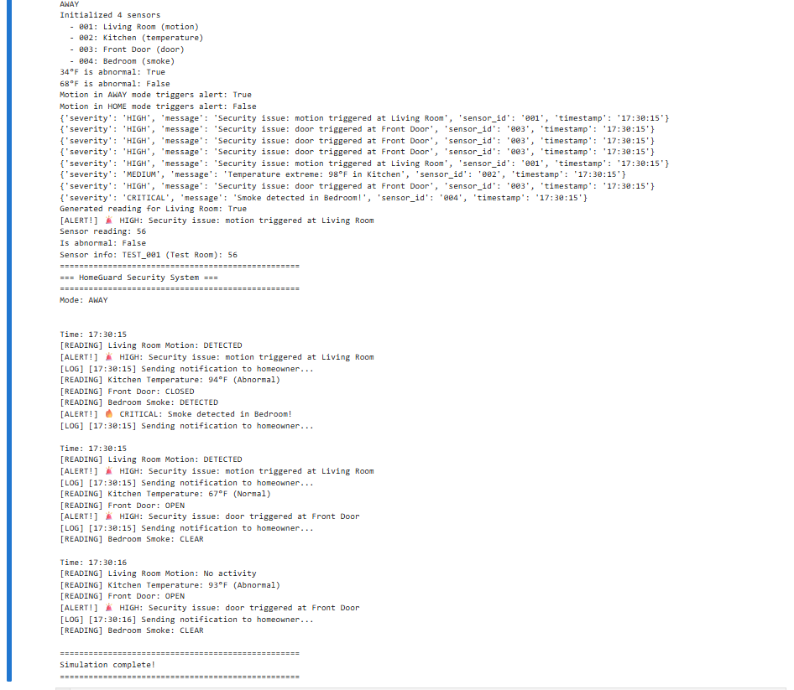

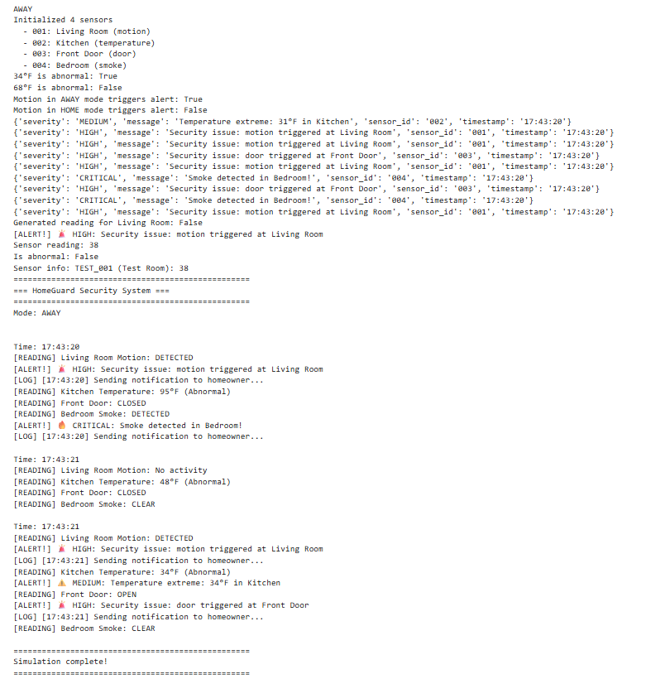

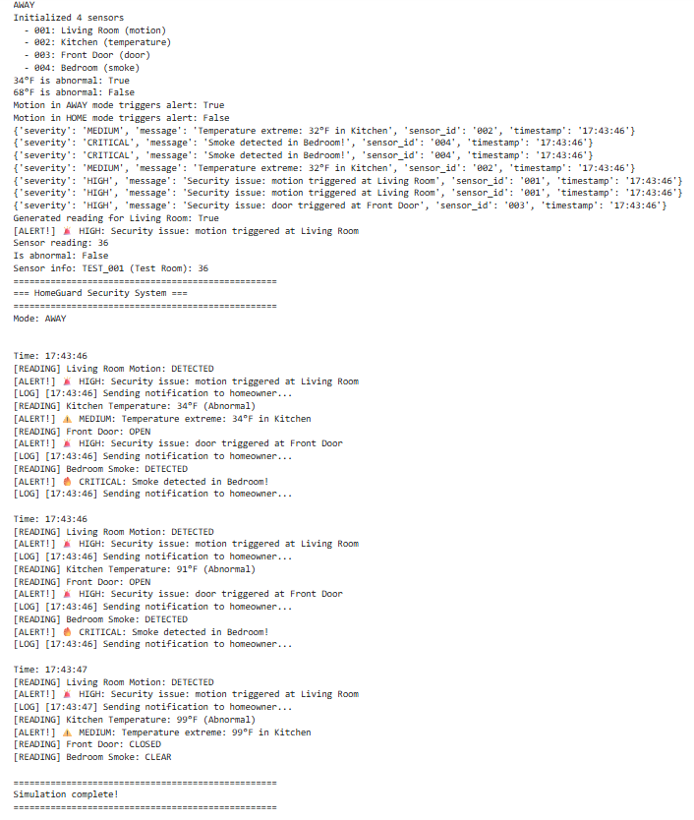

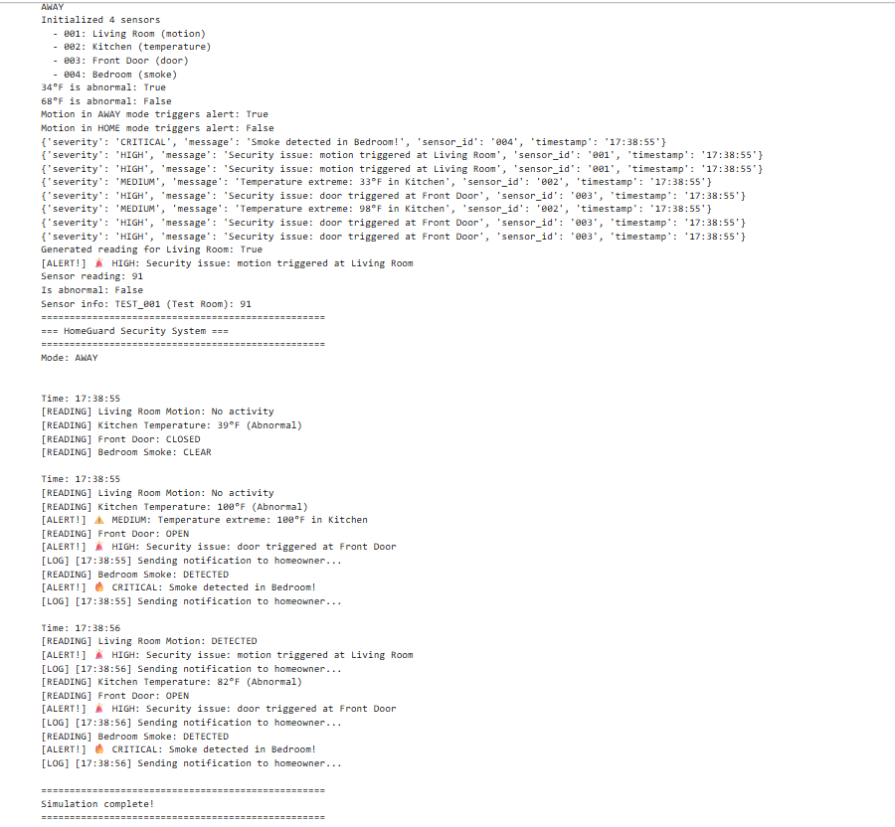

Simulations with “HOME” Mode

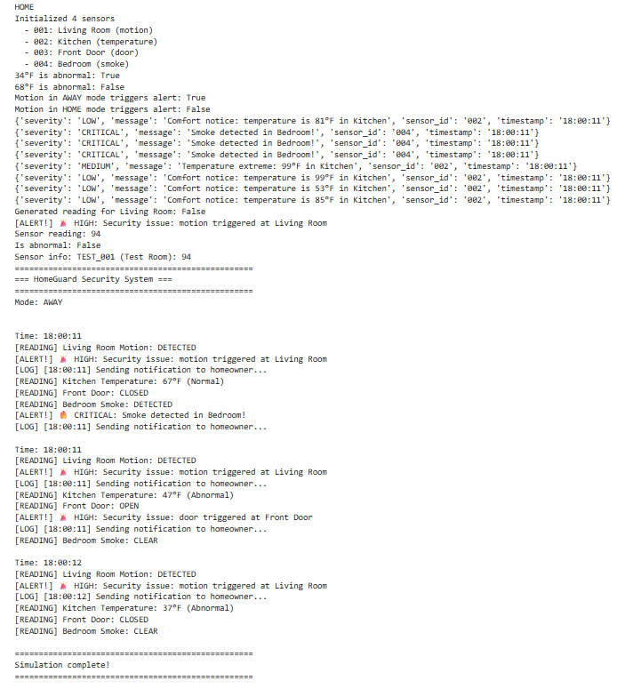

3. Simulation “SLEEP”

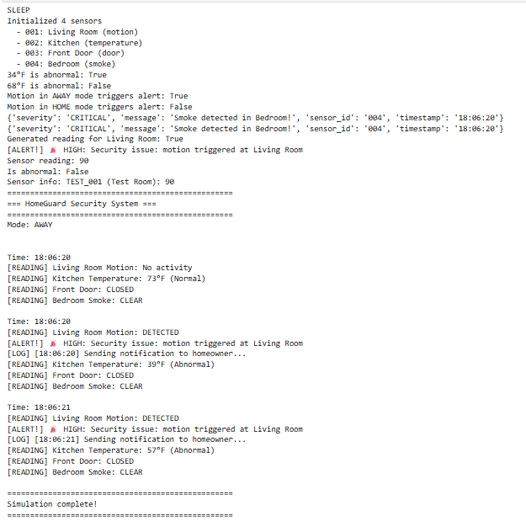

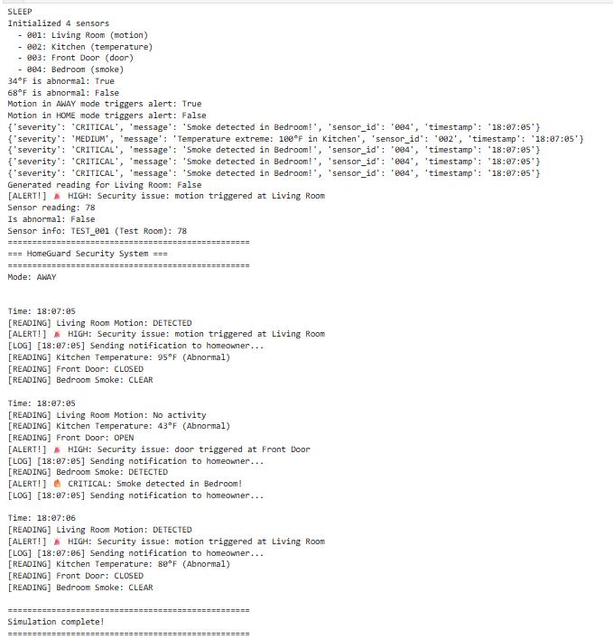

Questions: How the code works:
The program simulates a smart home by generating random sensor readings and processing each reading through a central function.

For every reading, the system checks security, safety, and comfort rules and creates alerts when conditions are met (for example motion in AWAY mode or extreme temperatures).
Pattern-based alerts, like a door being left open too long, work by remembering past sensor states and comparing them with the current time.

